**Motivation**

Watch the following example of the Milgram Experiment.

2006 (10 minutes)

<https://www.youtube.com/watch?v=y6GxIuljT3w>

What motivated these people to continue in the experiment? What motivated them to stop?

CONCEPT 1.1

SUMMARIZE MOTIVATION AND NEEDS THEORIES AND HOW THEY APPLY TO HUMAN BEHAVIOUR

**Definition: Need**

A condition of tension in an organism resulting from deprivation of something required for survival, well-being, or personal fulfillment.

________________________________________

VandenBos, G. R. (2007). APA Dictionary of Psychology.

**Definition: Want / Desire**

A longing or craving, as for something that brings satisfaction or enjoyment.

________________________________________

VandenBos, G. R. (2007). APA Dictionary of Psychology.

**Definition: Motivation**

The impetus that gives purpose or direction to human or animal behaviour and operates at a conscious or unconscious level. Motives are frequently divided into (a) physiological, primary, or organic motives, such as hunger, thirst, and need for sleep, and (b) personal, social, or secondary motives, such as affiliation, competition, and individual interests and goals. An important distinction must also be drawn between internal motivating forces and external factors, such as rewards or punishments that can encourage or discourage certain behaviours.

________________________________________

VandenBos, G. R. (2007). APA Dictionary of Psychology.

**Definition: Pleasure**

The emotion or sensation induced by the enjoyment or anticipation of what is felt or viewed as good or desirable.

________________________________________

VandenBos, G. R. (2007). APA Dictionary of Psychology.

**Definition: Unpleasure**

In psychoanalytic theory, the psychic pain, tension, and ego suffering that is consciously felt when instinctual needs and wishes, such as hunger and sex, are blocked by the ego and denied gratification at a conscious, preconscious, or unconscious level.

________________________________________

VandenBos, G. R. (2007). APA Dictionary of Psychology.

**Definition: Satisfaction of Instincts**

In psychoanalytic theory, the gratification of basic needs, such as hunger, thirst, sex, and aggression, which discharges tension, eliminates unpleasure, and restores the organism to a balanced state. Satisfaction may occur on a conscious preconscious, or unconscious level.

________________________________________

VandenBos, G. R. (2007). APA Dictionary of Psychology.

**Intrinsic motivation and the 16 basic desires theory**

Source: Reiss, Steven (March 5, 2002). Who am I? The 16 Basic Desires that Motivate Our Actions and Define Our Personalities. Berkley Trade. ISBN 978-0425183403.

Starting from studies involving more than 6,000 people, Professor Steven Reiss has proposed a theory that found 16 basic desires that guide nearly all human behavior. Intrinsic motivation is the tendency to find challenges, to push to find out for more, explore, and learn as much as possible. It is about reaching the most possible potential as a human being. The 16 basic desires that motivate our actions and define our personalities are:

Acceptance, the need for approval

Curiosity, the need to learn

Eating, the need for food

Family, the need to raise children

Honor, the need to be loyal to the traditional values of one's clan/ethnic group

Idealism, the need for social justice

Independence, the need for individuality

Order, the need for organized, stable, predictable environments

Physical activity, the need for exercise

Power, the need for influence of will

Romance, the need for sex and for beauty

Saving, the need to collect

Social contact, the need for friends (peer relationships)

Social status, the need for social standing/importance

Tranquility, the need to be safe

Vengeance, the need to strike back and to compete

CONCEPT 1.2

COMPARE MASLOW’S HIERARCHY OF NEEDS, ALDERFER’S ERG THEORY, AND MCCLELLAND’S NEEDS THEORY

**Maslow’s Hierarchy of Needs**

**Definition: Maslow’s Hierarchy of Needs**

The hierarchy of human motives, or needs, as described by humanist Abraham Maslow, which he developed as a reaction against the determinism of the theories of Sigmund Freud and B. F. Skinner. Physiological needs (air, water, food, sleep, sex, etc.) are at the base; followed by safety and security (the safety needs); then love, affection, and gregariousness (the love needs); the prestige, competence, and power (the esteem needs); and, at the highest level, aesthetic needs, the need for knowing, and self-actualization (the meta-needs).

________________________________________

VandenBos, G. R. (2007). APA Dictionary of Psychology.

**Definition: Physiological / Primary Need**

The first level in Maslow’s Motivational Hierarchy. An innate need that arises out of biological processes and leads to physical satisfaction.

________________________________________

VandenBos, G. R. (2007). APA Dictionary of Psychology.

**Definition: Safety Need**

The second level in Maslow’s Motivational Hierarchy. It consists of the need for freedom from illness or danger and the need for a secure, familiar, predictable environment.

________________________________________

VandenBos, G. R. (2007). APA Dictionary of Psychology.

**Definition: Belongingness / Love Need**

The third level in Maslow’s Motivational Hierarchy. The feeling of being accepted and approved by a group or by society as a whole.

________________________________________

VandenBos, G. R. (2007). APA Dictionary of Psychology.

**Definition: Esteem Need**

The fourth level in Maslow’s Motivational Hierarchy characterized by striving for a sense of personal value derived from achievement, reputation, or prestige. In this level of development, the admiration and approval of others leads to the development of self-esteem.

________________________________________

VandenBos, G. R. (2007). APA Dictionary of Psychology.

**Definition: Self-actualization Need**

The fifth level in Maslow’s Motivational Hierarchy. According the Abraham Maslow, it is the “full use and exploitation of talent, capacities, potentialities” such that the individual develops to maximum self-realization, ideally integrating physical, social, intellectual, and emotional needs.

________________________________________

VandenBos, G. R. (2007). APA Dictionary of Psychology.

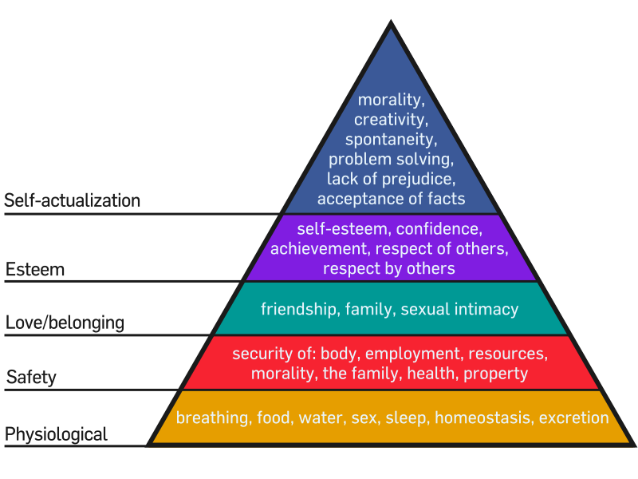

Source: https://commons.wikimedia.org/wiki/File:Maslow%27s_Hierarchy_of_Needs.svg

**Alderfer’s ERG Theory**

**Definition: Alderfer’s ERG Theory**

ERG theory is a theory in psychology proposed by Clayton Alderfer. Alderfer further developed Maslow's hierarchy of needs by categorizing the hierarchy into his ERG theory (Existence, Relatedness and Growth). The existence group is concerned with providing the basic material existence requirements of humans. They include the items that Maslow considered to be physiological and safety needs. The second group of needs is those of relatedness – the desire people have for maintaining important interpersonal relationships. These social and status desires require interaction with others if they are to be satisfied, and they align with Maslow's social need and the external component of Maslow's esteem classification. Finally, Alderfer isolates growth needs: an intrinsic desire for personal development. These include the intrinsic component from Maslow's esteem category and the characteristics included under self-actualization.

Alderfer categorized the lower order needs (Physiological and Safety) into the Existence category. He fit Maslow's interpersonal love and esteem needs into the Relatedness category. The Growth category contained the self-actualization and self-esteem needs. Alderfer also proposed a regression theory to go along with the ERG theory. He said that when needs in a higher category are not met then individuals redouble the efforts invested in a lower category need. For example if self-actualization or self-esteem is not met then individuals will invest more effort in the relatedness category in the hopes of achieving the higher need.

________________________________________

Source : Alderfer, Clayton P. (1969). "An empirical test of a new theory of human needs". Organizational Behavior and Human Performance. 4 (2): 142–75.

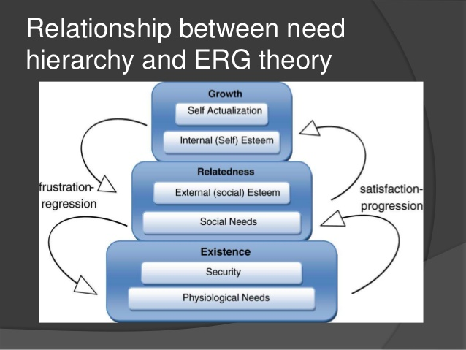

**McClelland’s Needs Theory**

**Definition: McClelland’s Learned Needs Theory**

“…psychologist David McClelland further investigated this idea [Maslow’s idea of individual characteristics influence the strength of higher order needs] that a person’s needs can be strengthened through reinforcement, learning, and social conditions. McClelland examined three of these “learned” needs: achievement, power, and affiliation.”

________________________________________

Source : McShane, S. L., & Steen, S. L. (2009). Canadian Organizational Behaviour (7th ed., pp. 111). McGraw-Hill Ryerson.

**Definition: Need for Achievement (nAch)**

People with a strong need for achievement (nAch) want to accomplish reasonably challenging goals through their own effort. They prefer working alone rather than in teams and they choose tasks with a moderate degree of risk. High nAch people also desire unambiguous feedback and recognition for their success. Money is a weak motivator, except when it provides feedback and recognition. In contrast, employees with a low nAch perform their work better when money is used as an incentive. Successful entrepreneurs tend to have a high nAch, possibly because they establish challenging goals for themselves and thrive on competition.

________________________________________

Source : McShane, S. L., & Steen, S. L. (2009). Canadian Organizational Behaviour (7th ed., pp. 111). McGraw-Hill Ryerson.

**Definition: Need for Affiliation (nAff)**

Need for affiliation (nAff) refers to a desire to seek approval from others, conform to their wishes and expectations, and avoid conflict and confrontation. People with a strong nAff try to project a favourable image of themselves. They tend to actively support others and try to smooth out workplace conflicts. High nAff employees generally work well in coordinating roles to mediate conflicts, and in sales positions where the main task is cultivating long-term relations. However, they tend to be less effective at allocating scarce resources and making other decisions that potentially generate conflict. People in decision-making positions must have a relatively low need for affiliation so that their choices and actions are not biased by personal need for approval.

________________________________________

Source : McShane, S. L., & Steen, S. L. (2009). Canadian Organizational Behaviour (7th ed., pp. 111). McGraw-Hill Ryerson.

**Definition: Need for Power (nPow)**

People with a high need for power (nPow) want to exercise control over others and are concerned about maintain their leadership position. They frequently rely on persuasive communication, make more suggestions in meetings, and tend to publicly evaluate situations more frequently. McClelland pointed out that there are two types of nPow. Those who enjoy their power for its own sake, use it to advance personal interests, and wear their power as a status symbol have **personalized power**. Others mainly have a high need for **socialized power** because they desire power as a means to help others. Alderfer categorized the lower order needs (Physiological and Safety) into the Existence category. He fit Maslow's interpersonal love and esteem needs into the Relatedness category. The Growth category contained the self-actualization and self-esteem needs. Alderfer also proposed a regression theory to go along with the ERG theory. He said that when needs in a higher category are not met then individuals redouble the efforts invested in a lower category need. For example if self-actualization or self-esteem is not met then individuals will invest more effort in the relatedness category in the hopes of achieving the higher need.

________________________________________

Source : McShane, S. L., & Steen, S. L. (2009). Canadian Organizational Behaviour (7th ed., pp. 111). McGraw-Hill Ryerson.

**Elizabeth Keen**

Need for Achievement (nAch)

Need for Power (nPow) – Personal and Socialized

**Harold Cooper**

Need for Achievement (nAch)

Need for Power (nPow) – Personal and Socialized

**Raymond Reddington**

Need for Achievement (nAch)

Need for Power (nPow) – Personal and Socialized

Are all three characters actually motivated similarly??